Janata Shikshan Sanstha’s
Kisan Veer Mahavidyalay, Wai
Departments of Commerce and Economics
Report of Outreach Financial literacy Programme – 01st October 2019
One Day workshop on “Outreach Financial Literacy Programme” was organized by Departments of Commerce and Economics of our college in association with Reserve Bank of India and Bank of Maharashtra on 01st October 2019; considering the central role of Reserve Bank of India in Indian and international financial system. Reserve Bank of India plays a vital role in economic, financial and monetary measures in India’s economy and has positive – negative repercussions at the international level. The monetary and financial decisions taken by RBI are always find out of general public understanding i.e. printing notes, repo rate, decision related to withdraw/ deposit money etc. This kind of education must be impart to the person who is good aware with currency, through the outreach financial literacy programme RBI is imparting this materialistic education to students who are good aware of money and financial system and they will be next ambassador of RBI’s financial education in masses.
Hon. Vasant Ghagare (Zonal Manager, Bank of Maharashtra) with his auspicious hands inaugurated workshop by enlightening holy lamps and offering flower to frames of Hon. Abbasaheb Veer and Hon. Laxman Shatri Joshi along with all dignitaries on dais. Hon. Vsant Ghaghare delivered his inaugural speech followed by introduction of this programme by Mr. Nitiraj Sable, (FLC, Bank of Maharashtra). The method of phishing by some experts how caught the common people in their net and presence financial phishing scams were the main issues on which Hon. Ghaghare spoke and made aware to all presented audience. Hon. Suraj Ponkshe (Manager, Resereve Bank of India, Mumbai) was the chief guest and key note speaker of this programme, delivered full length speech on Reserve Bank of India’s Working, Functioning and Recruitment. He synchronized each of recently mentioned topics in detail. In order to raise student’s response in interaction, Mr. Suraj Pokshe asked some questions and made students talking to. Mr. Suraj Ponkshe encompassed following points in his key note speech i.e. role of RBI in Indian and International financial system as well as in monetary system, employment opportunities in RBI and other banks, insurance and its importance etc. besides they appealed students that, all you students are a brand ambassador of RBI and you shall convey the message of RBI to unaware class of society.
Mr. Nitiraj Sable arranged quiz competition next to chief guest lecture. He asked 10 questions on general knowledge that students have heard in Mr. Suraj Ponkshe’s lecture and awarded those 10 students who have given correct answer first. Beside this, all participant students got one special wrapper of gift from RBI and Bank of Mahrashtra. At the end, Hon. Principal Dr. C. G. Yeole in their speech offered sincere thanks to RBI and Bank of Maharashtra for arranging such programme in our college. Hon. Principal appealed students to use maximum technology in financial affairs and make your transactions very fast and seamless. Academic and sound education is necessary but financial education is also significant now days, so all people should start the learning of financial education. Registered 210 Students and about 50+ unregistered students along with Teaching and Non-teaching staff were participated in this progamme. Dr. R. S. Gavit, Convener of programme and HOD of Economics, presented vote of thanks and declared that, the programme is concluded by the permission of Chairman.

Hon. Vasant Ghaghare, Zonal Manager, BOM, Inaugurating Programme
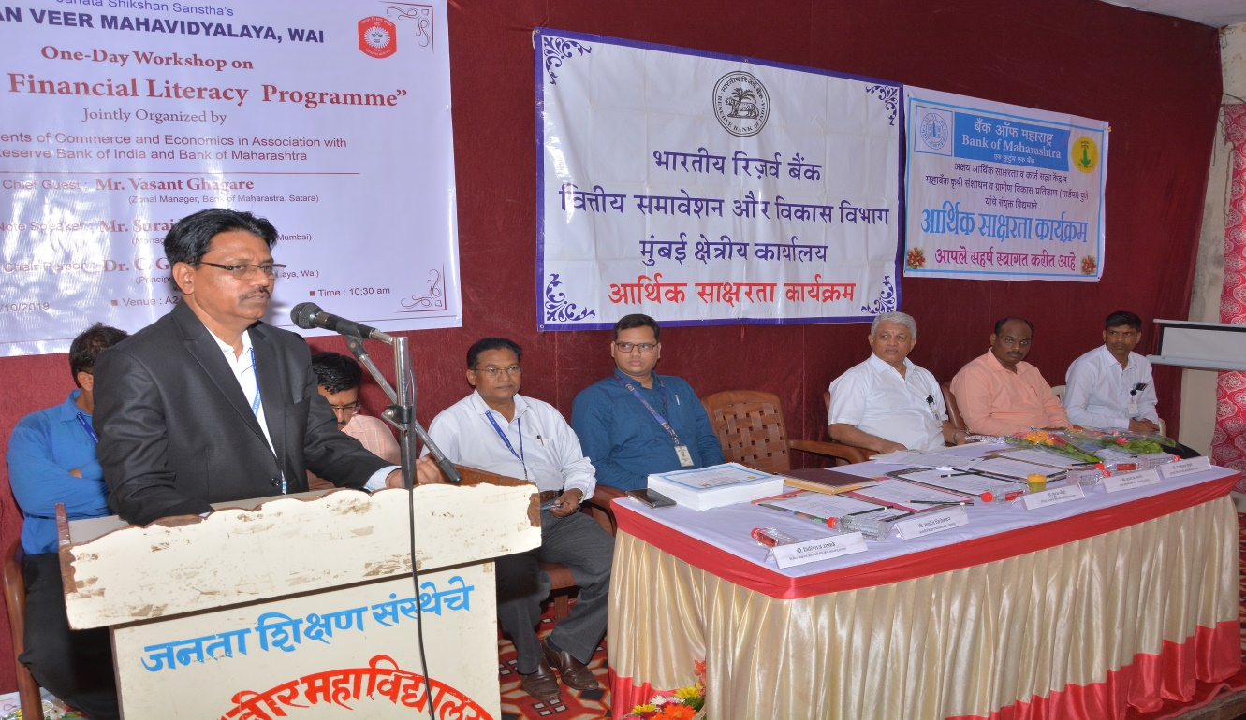
Hon. Suraj Ponkshe, Manager, RBI, Introducing Programme
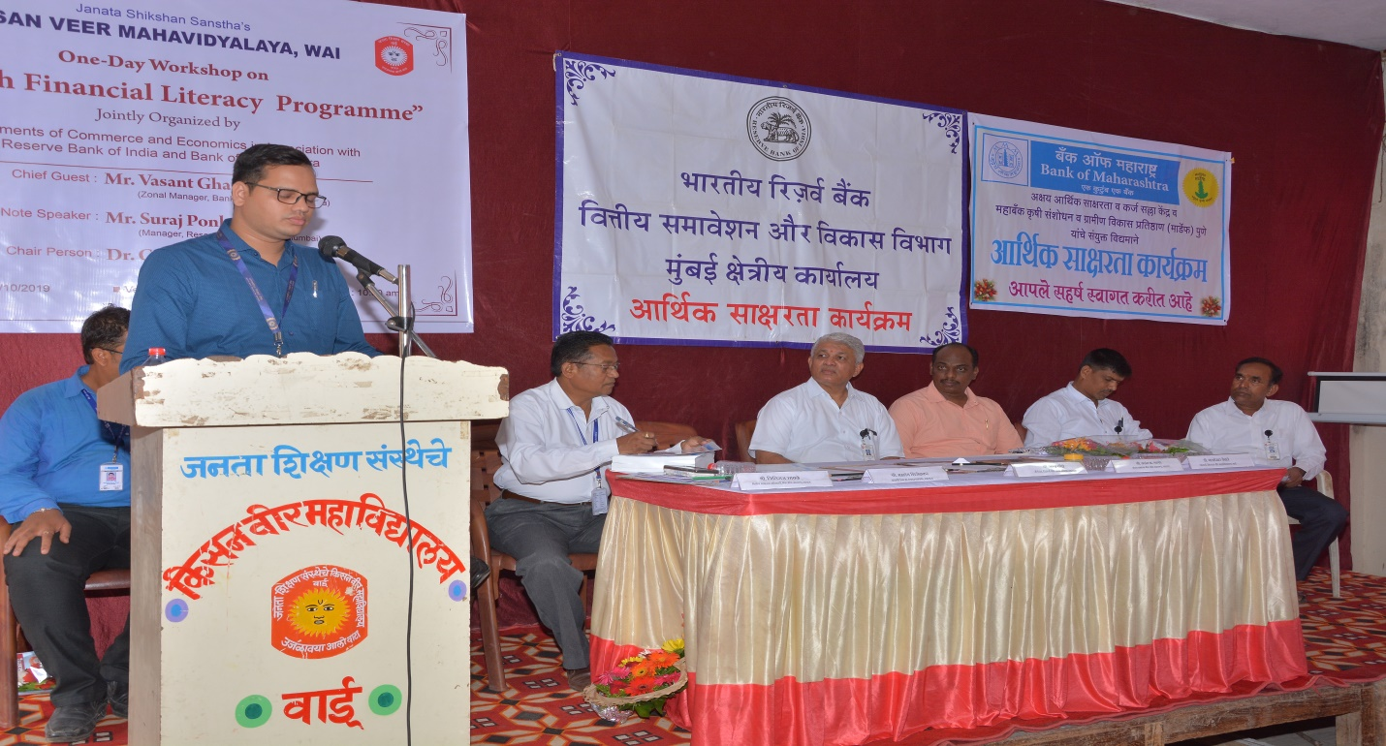

Hon. Principal Dr. C. G. Yeole’s Presidential Address
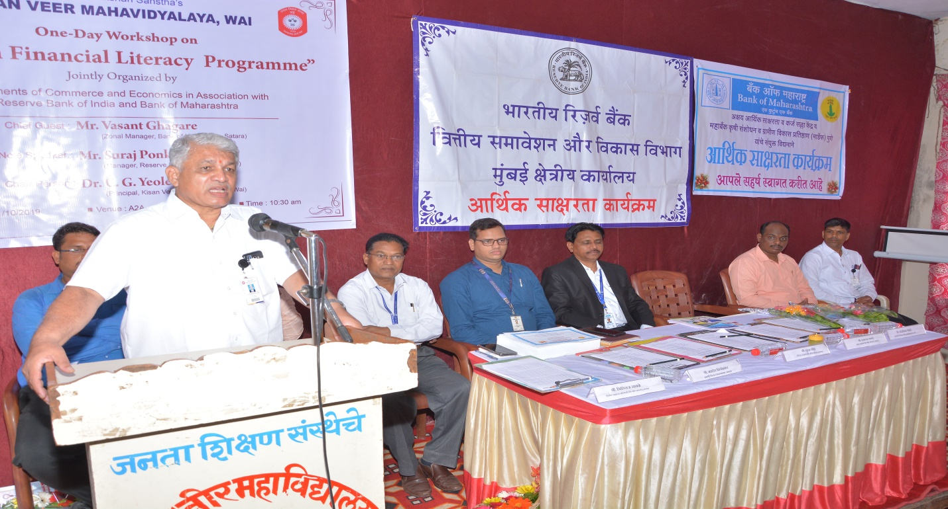
Hon. Suraj Ponkshe, Manager, RBI, Addressing to Students
